Project Progress Report 2

(due May 24th 11:59p.m)

Yijun Luo

You can start working on the project once your report is accepted and graded by your TA. The entire final project is worth **35%** of your final grade and this report accounts for **10%**. This project is done individually.

**Submission Guideline**

Download this google doc, fill the table. **Type** your answers, no handwritten answers will be accepted (except for the very last question). Submit it in **PDF** format on Gradescope.

If you need some inspirations please feel free to take a look at:

[Showcase of Information is Beautiful Awards](https://www.informationisbeautifulawards.com/showcase?page=1&pcategory=winner&type=awards)

[Bloomberg Year In Graphics Review](https://www.bloomberg.com/graphics/2022-in-graphics/#xj4y7vzkg)

[The Pudding](https://pudding.cool/)

[The New York Times](https://www.nytimes.com/interactive/2022/12/28/us/2022-year-in-graphics.html)

# Project Guidelines

**Note: The guideline has been further clarified from Progress Report 1, so double-check whether your dataset choice still satisfies the updated guideline below.**

1. You may use more than one dataset, however, regardless of you use one or multiple datasets, your visualizations must make use of at least three following data types - **link, position, and attribute.**
2. You cannot use any dataset from the class (Labs, Assignments, Lecture Exercises)
3. You can make your own dataset (Web scrape etc.) provided point 1. is satisfied.

## Part 1 - Story and Narrative

|  |  |
| --- | --- |
| Link to the dataset | <https://www.kaggle.com/datasets/surajjha101/forbes-billionaires-data-preprocessed> (2022 Kaggle)  <https://www.forbes.com/billionaires-2022/> (2022)  <https://www.forbes.com/billionaires/> (2023) |
| Example item from the dataset | Elon Musk, $180 B, 51, US, Tesla SpaceX, Automotive |
| Story you want to deliver | (a story should be in a form of a list of facts, insights, and messages - refer to the lecture slide)  Total net worth of all billionaires in 2023 is less than that of 2022 shows the general recession of global economy.  The decrease of wealth of most billionaires demonstrates overall depression of global economy this year.  Bernard Arnaut replace Elon Musk as the world’s richest person and many other owners of luxury brands rise on the ranking shows a stronger and sooner recovery in the industry of luxury than any other industries.  The decrease of wealth of nearly all owners of IT companies corresponds with vast job cut among IT companies this year. |
| Describe your target audience. | (using the questions the lecture slide listed)  The target audience is investors, venture capital firm, and everyone who is interested in commercial or stock market  Familiarity with my topic: definitely know some celebrity or famous brand or company.  Do their care: most will be curious about top richest people in the world, but might not care too much if not work in field full of billionaires or field of investment.  What do I want them to take away: key changes among all industries behind the change of ranking of billionaires.  What do they know about visualization: they do not need to have too much knowledge about visualization, my visualization will be standard and self-explanatory.  How do they encounter my visualization: they will encounter during the process of going through my webpage instead of showing them straight ahead when they open the page  Mathematical background: do not need too much  Device: computer and mobile phone |
| The goal of your project outcome. And why? | (exploratory vs. explanatory)  Explanatory because my goal is more focus on communication my idea to general audience instead of doing analysis for domain experts. And my story will be more human center. |
| Narrative structure you plan to use | Martini-glass structure |
| Elaborate your choice of narrative structure. | I choose Martini-glass structure because I want to provide some guidance to my audience first, like the overall trend of economy these two years, and then let them to explore themselves through some my interactive visualization, and reach to the point want to make but not giving much lecture and intentional messaging |
| Narrative genre you plan to use | Combination of slide show and annotated chart |
| Elaborate your choice of narrative genre. | The effect I want to achieve is that audience will explore since my narrative structure is Martini-glass, so when they click one category of billionaires, it will guide them to another page like a slide show, but within that page, it will be a annotated chart to explain the visualization |

## 

## Part 2 - Outline

|  |  |
| --- | --- |
| Story you want to deliver | (you can copy/paste from Part 1)  Total net worth of all billionaires in 2023 is less than that of 2022 shows the general recession of global economy.  The decrease of wealth of most billionaires demonstrates overall depression of global economy this year.  Bernard Arnaut replace Elon Musk as the world’s richest person and many other owners of luxury brands rise on the ranking shows a stronger and sooner recovery in the industry of luxury than any other industries.  The decrease of wealth of nearly all owners of IT companies corresponds with vast job cut among IT companies this year. |
| Specifications on each plot **in the order of how you lay out on your project** | (for each plot, include 1) clear task abstraction, 2) attributes used, 3) marks, 4) channels, and 5) how this plot adds to the story)  **Plot 1**   1. Task: This chart mainly compares the total wealth of Forbes billionaires each year, also the growth and decline of proportion of billionaires in each industry 2. Attributes: Year, total wealth, category 3. Marks: Lines 4. Channels: Position, color, and size 5. How this plot adds to story: This visualization shows economic decline after covid, and economic downslide of 2023 compare with 2022   **Plot 2**   1. Task: These pair of line charts present development trend of luxury industry and technology industry between 2022 and 2023 2. Attributes: Year, wealth, name 3. Marks: points 4. Channels: Position and color 5. How this plot adds to story: These two line charts that show the trend of luxury and technology industry between 2022 and 2023, it reflects the insight that Bernard Arnaut replace Elon Musk as the world’s richest person and many other owners of luxury brands rise on the ranking shows a stronger and sooner recovery in the industry of luxury than any other industries.   **Plot 3**   1. Task: Analyze billionaires and their wealth between each country (y axis have the option to be switched between number of billionaires and total wealth) 2. Attributes: country, wealth, number of people, industry 3. Marks: lines 4. Channels: Position, color, and size 5. How this plot adds to story: This bar chart compares richest people among each country and what industry make people in those countries wealthy, this reflects the economic structure of a country in a certain sense |
| Elaborate the choice of their marks and channels for each vis | **Plot 1**  Choose line for marks because it is the accumulated amount of wealth.  Choose position for channel because it can reflect the amount of wealth very well. Choose color because it can be used to identify different industries, and industry is a categorical value, color is good at doing this, it does not give meaning of ordinal and size. Choose area because it reflects how much proportion each industry account for in the total wealth.  **Plot2**  Choose point as marks because each point essentially says how much wealth a person have at certain year  Choose position to show how much wealth that person have on a scale. Use color to identify different billionaires, they are categorical.  **Plot3**  Use line for marks because it represents the accumulated amount of wealth or number of people for each country.  Use position for channel because it can reflect the amount of wealth very well. Use color because it can be used to identify different industries, and industry is a categorical value, color is good at doing this, it does not give meaning of ordinal and size. Use area because it reflects how much proportion each industry account for in the total wealth of that country. |

Following sample answer about a single plot shows how detailed your answers to part 2 should be.

|  |
| --- |
| 1. Plot 1   1. Task: This chart a) analyzes trend between Height and Weight of patients with heart diseases and b) locates outliers within the patients 2. Attributes: Height, Weight 3. Marks: point mark 4. Channels:    * aligned vertical position channel for Height    * aligned horizontal channel for Weight 5. How this plot adds to the story:   My visualizations aim to deliver health characteristics of patients with heart disease. This plot will provide more specific insights on Height and Weight. |

## Part 3 - Prototype

Provide a photo or screenshot of your prototype. A prototype should depict how you place different components of your visualization. You may use pen-paper, or using tools like excalidraw, figma etc.

A basic, barebones sample prototype for this project

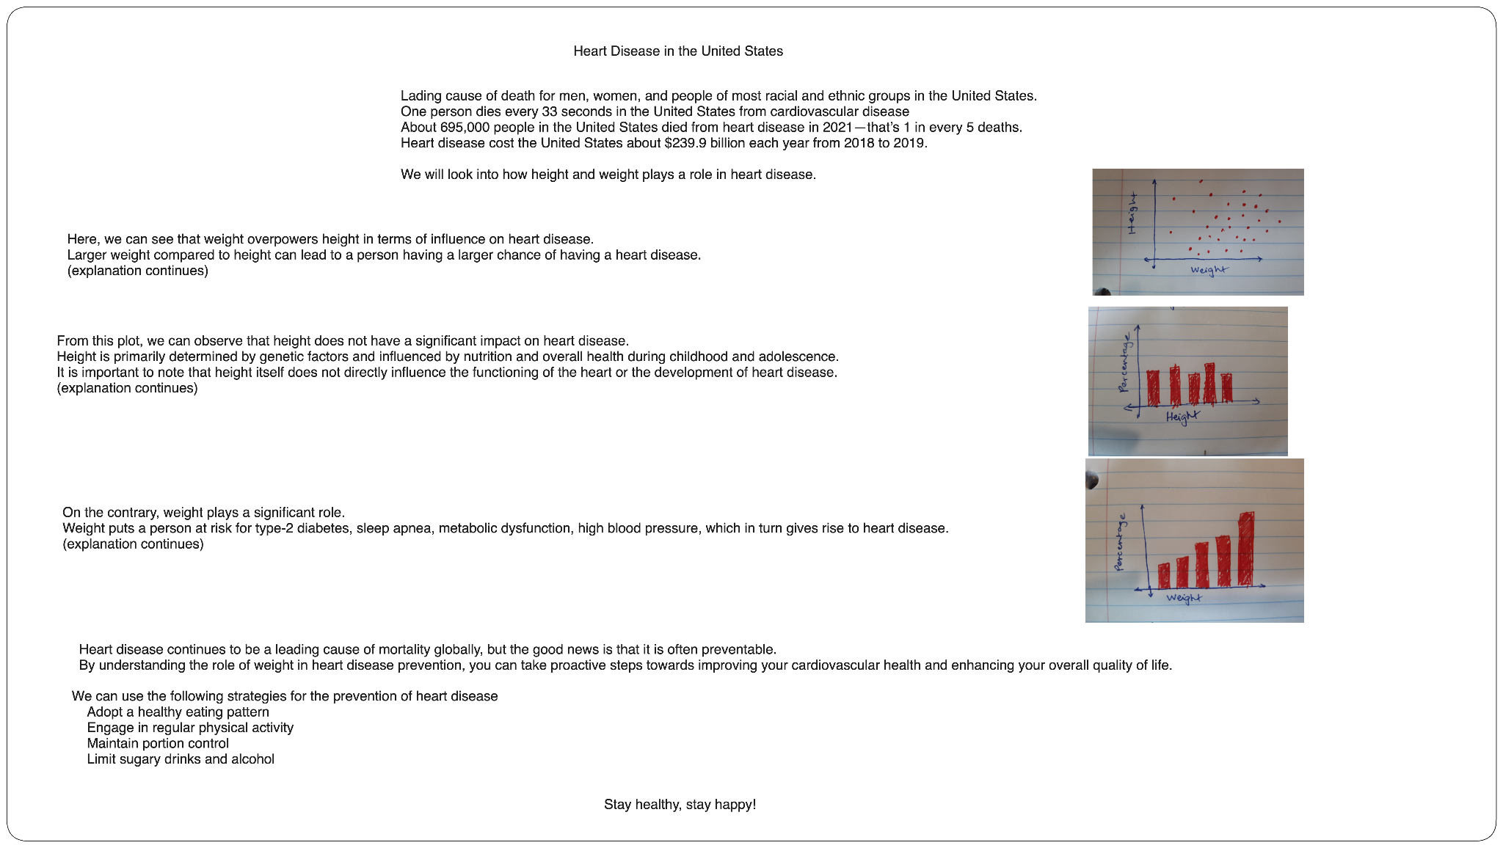

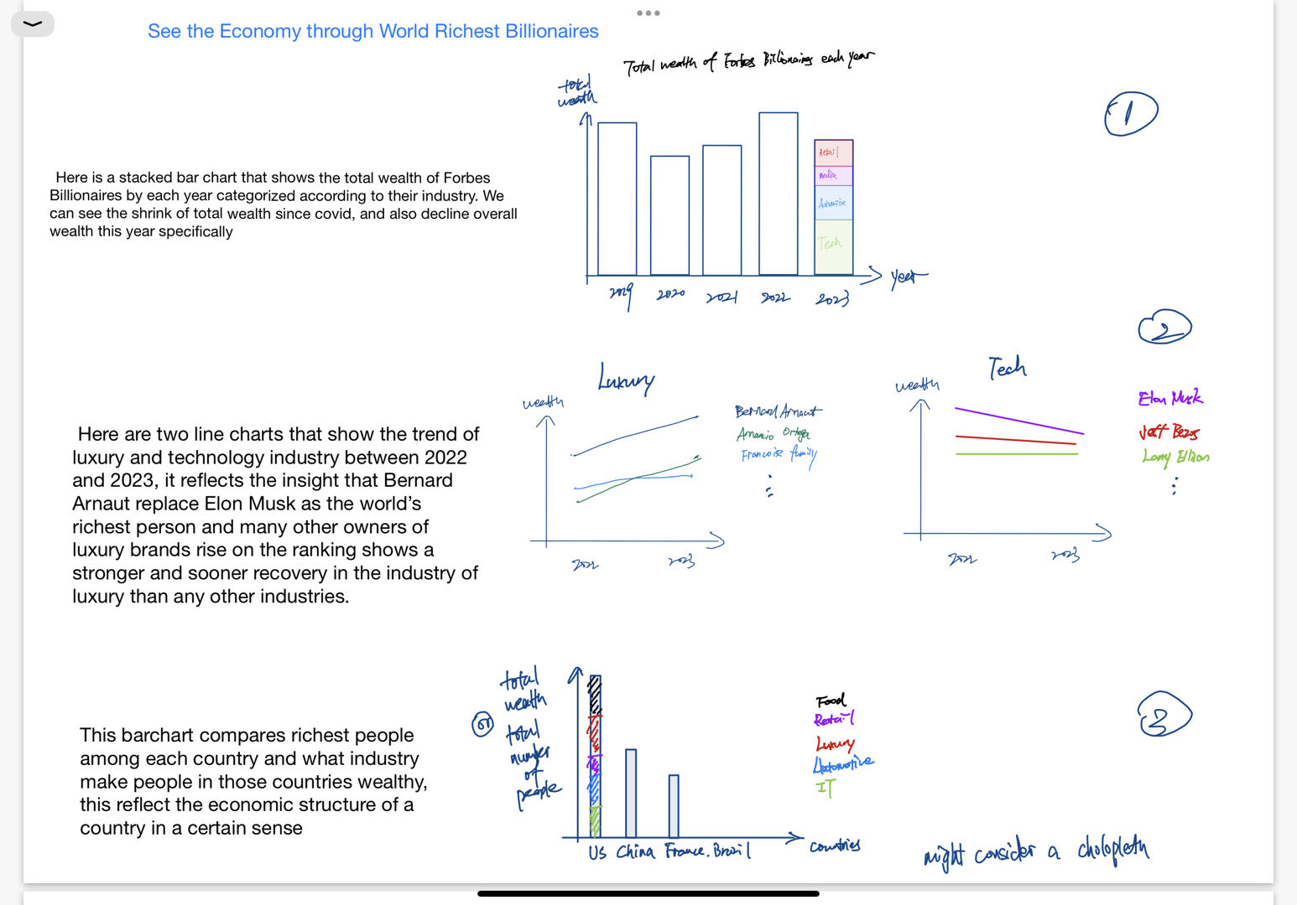

This is just the prototype. In the final version, might consider a network/tree graph in to display relationship between billionaires and their companies. Will also have more detailed visualizations about several billionaires individually such as Elon Musk, Bernard Arnaut to better tell my story.